CHAPTER-1
INTRODUCTION

1.1 Need Of The Website
- The website on e-commerce is needed in that it will make the buying of plants easy and convenient. One can shop while at home, with numerous types of plants to choose from and in-depth information about the care of the plant.
- The website can offer professional tips, subscription options for regular plant deliveries, and customizable orders with options such as eco-friendly choices. All in all, this will make it easier for them to search for and buy plants; that is, more accessible and efficient for the lovers of plants.

1.2 Detailed Problem Definition
- Many local stores in towns or cities can barely sell a certain range of plants, often excluding rare or exotic species that customers might be interested in. This makes it infuriating for any sort of plant enthusiast who wants to look for specific species or any different kinds of plants.
- Shopping for plants in physical stores is a big waste of time. In addition, he must travel to various shops to get the plants of their choice, manage according to shop timings, and handle the traveling hassle. A user friendly front-end for the user to interact with the system.
- Plant delivery includes several other issues concerning the perfect packaging, maintenance of shipping conditions, and scheduled delivery. All these issues may further cause damage to the plants and make delays in deliveries, lowering customer satisfaction.

1.3 Viability Of The System
- First and foremost, it is market demand. People are becoming increasingly interested in plants for fashion trends in interior design, sustainable living, and individual health. This market demand needs to be understood; you would like to make certain that there is huge and continuous interest in buying plants and related products online.
- Here, there may be established players in the e-commerce plant market, so it is required of you to research the existing competition. Scrutinize the rival's strengths and weaknesses for opportunities where you can delineate your website.

1.4 Presently Available Website
- https://www.santhionlineplants.com
- The site offers a diverse selection of plants, including indoor plants, outdoor plants, flowering plants, and succulents.

1.5 Future prospects
- Growing consumer preference for convenient online plant shopping.
- Enhanced Website.
- Personalized shopping experiences and advanced customer support tools.

CHAPTER-2
ANALYSIS

2.1 Requirement Analysis
User Roles
- Admin - Manage products (add, edit, delete). View, process, and update orders. Manage user accounts (view, delete). View analytics and sales reports.
- Customer - Browse product categories. View product details and reviews. Add products to the shopping cart. Purchase products using different payment methods. Leave product reviews.

Product Management
- Product Information - Product name, description, price, size. Stock availability. Care instructions (water, sunlight, fertilizer requirements). Customer ratings and reviews.

Order Management
- For Customers - Add/remove products from the cart. Checkout process (address, payment, review order).
- For Admin - View all orders (pending, completed, shipped). Update order statuses (pending, processing, shipped, delivered).

Payment System
- Secure payment integration (e.g., PayPal, cash on delivery). Apply discount codes, coupons, or offers. Support for multiple currencies (optional, if international shipping is provided).

Reviews and rating
- Customers can leave reviews and star ratings on products they purchase. Reviews should be displayed on the product detail page. Admin should be able to moderate reviews (approve/delete inappropriate reviews).

Customer Support
- FAQ section for common questions regarding plants and gardening care. Return/refund policies.

User Account Management
- User registration and login (email/password, social media login). Profile management (update name, email, password, delivery addresses).

2.2 Project Model
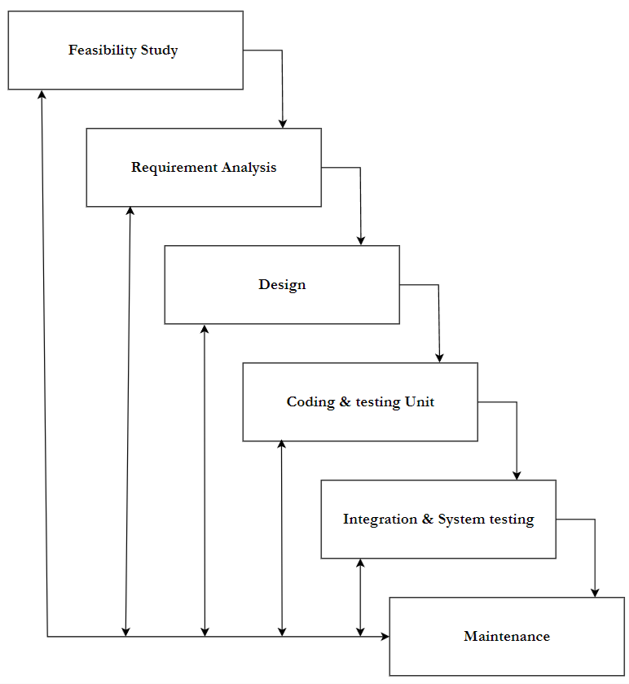
[Figure 1: Iterative Waterfall Model]
- This application is developed using Iterative model. Almost every other model is derived from the waterfall model.
- The phase of detecting errors is close to its points of introduction is known as face containment of errors.
- Incremental model is also referred as the successive version of waterfall model using incremental approach and evolutionary model.
- In this model, the system has broken down into several modules which can be incrementally implemented and delivered.
- First develop the core model and when customer evaluate the system then the initial product skeleton is redefined into increasing levels capacity by adding new functionalities in successive versions.

Advantages
- Each successive version performing more useful work than previous versions.
- The core modules get tested thoroughly, thereby reducing change of error in final product.
- The model is more flexible and less costly to change the scope and requirement.
- User gets a change to experiment with partially developed software.
- This model helps finishing exact user requirements.
- Feedback providing at each increment is useful for determining the better final product.

2.3 Schedule Representation
Generalized project scheduling tools and technique can be applied with little modification to software projects.
Project evolution and review technique and critical paths method are two project scheduling method that can be applied to software development. Both techniques are driven by information already developed in earlier project planning activities:
- A decomposition of the product function.
- The selection of appropriate process model and task set.
- Estimate of effort.
- Decomposition

[Table 1: Schedule Representation]
ACTIVITY | START DATE | FINISH DATE
Requirement Analysis
System Analysis
System Design
System Coding
Testing and Integration

2.4 Feasibility Study
2.4.1 Technical Feasibility
- The proposed system will be developed in web bases completely and it is required to use web technologies appropriately. Technology to build the overall system is available.
- Currently Available web technology - HTML, CSS, JavaScript (front-end) and Python (Django/Flask), Node.js (back-end).
- Servers – pyhtonanywhere
- DBMS – MySql

2.4.2 Economical Feasibility
- Economic feasibility is the most frequently used method for evaluating the effectiveness of a new system. More commonly known as cost/benefit analysis, the procedure is to determine the benefits and savings that are expected from a candidate system and 8 compare them with costs. If benefits outweigh costs, then the decision is made to design and implement the system.

2.4.3 Operational Feasibility
- Definition: Operational feasibility assesses how effectively a proposed system addresses the identified problems and leverages opportunities from the scope definition and problem analysis phases, and how well it satisfies the system requirements from the requirement analysis phase.
- User Familiarity: The potential users of the Plants and Greenery e-commerce website will be familiar with basic web navigation and interaction, making the training process straightforward and efficient. Basic training on managing products, processing orders, and using admin functionalities will be sufficient for most users.
- Data Security: The system will include robust security features by implementing multiple access levels for various users (e.g., admin, vendor, customer). Secure authentication, authorization, and auditing procedures will be in place to safeguard sensitive data and provide system administrators with full control over the site’s operations.
- Data Management: Data retrieval for products, customer details, and orders will be efficient. Advanced querying mechanisms, search filters, and backend database management systems (such as MySQL or SQLite) will ensure quick and smooth data access.

CHAPTER-3
DESIGN

3.1 Data Flow Diagram
- DFD (data flow diagram) is also known as bubble chart or data flow graph.
- DFD’s are very useful in understanding the system and can be effectively used during analysis. It shows flow of data through a system visually. The DFD is a hierarchical graphical model of a system the different processing activities or functions that the system performs and the data interchange among these functions.
- It views a system as a function that transforms the inputs into desired output.
- Each function is considered as a process that consumes some input data and produces some output data.
- Function model can be represented using DFD.
- DFD graphically representing the functions, or processes, which capture, manipulate, store, and distribute data between a system and its environment and between components of a system.
- The visual representation makes it a good communication tool between User and System designer.
- Structure of DFD allows starting from a broad overview and expand it to a hierarchy of detailed diagrams.
- DFD has often been used due to the following reasons:
- Logical information flow of the system.
- Determination of physical system construction requirements.
- Simplicity of notation.
- Establishment of manual and automated systems requirements.

[Table 2: Data Flow Diagram Symbols]
Symbols | Description
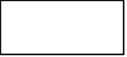 | Entity: Entities are external to the system which interacts by inputting the data.
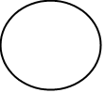 | System: It shows the system name.
 | Process: It shows the part of the system that transforms into outputs.
 | Data Flow: It passes the data from one part to another.
 | Data Store: Data store is represented by two parallel lines. It is generally logical file or database.

Level 0: Context
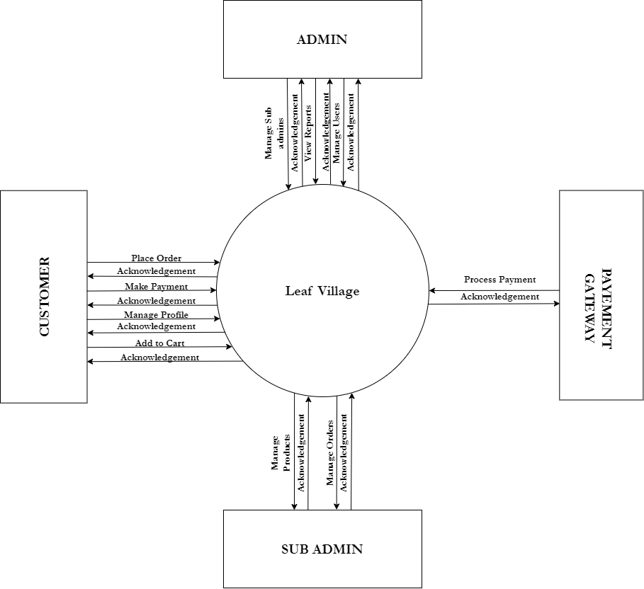
[Figure 2: Context level]

Level 1: Admin
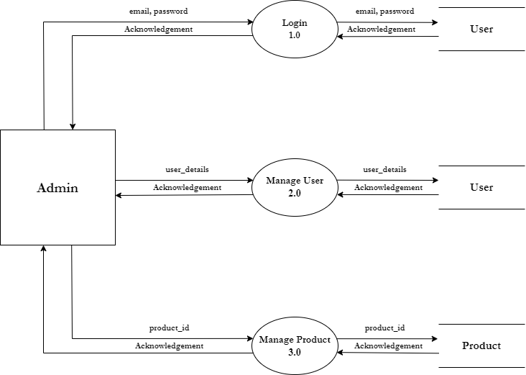
[Figure 3: DFD Level 1: Admin]

Level 1: Customer
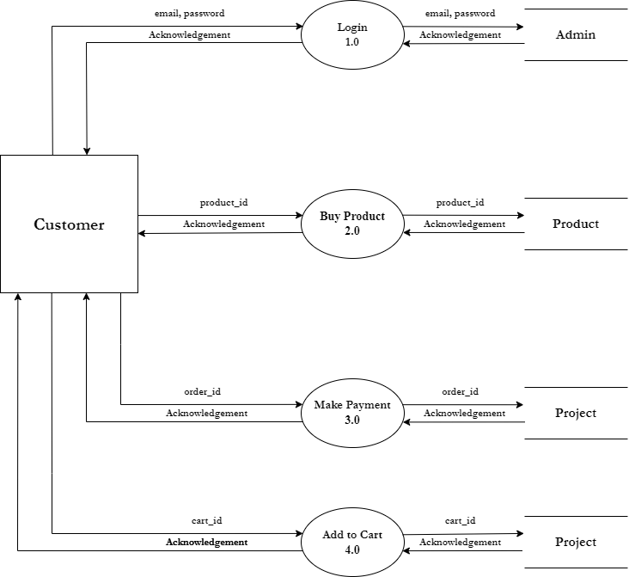
[Figure 4: DFD Level 1: Customer]

Level 1: Payment Gateway
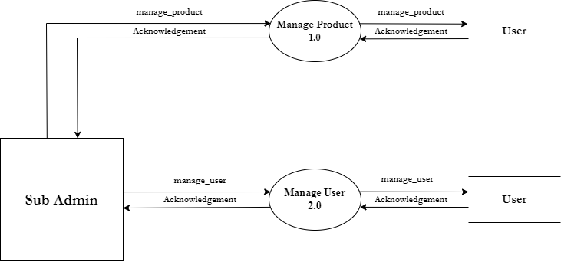
[Figure 5: DFD Level 1: Payment Gateway]

Level 1: Sub Admin
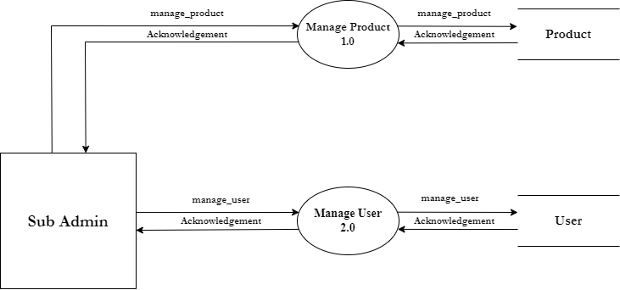
[Figure 6: DFD Level 1: Sub Admin]

3.2 ER-Diagram
An Entity Relationship (ER) Diagram is a type of flowchart that illustrates how “entities” such as people, objects or concepts relate to each other within a system. ER Diagrams are most often used to design or debug relational databases in the fields of software engineering, business information systems, education and research. Also known as ERDs or ER Models, they use a defined set of symbols such as rectangles, diamonds, ovals and connecting lines to depict the interconnectedness of entities, relationships and their attributes. They mirror grammatical structure, with entities as nouns and relationships as verbs.

[Table 3: ER-Diagram Symbols]
Symbols | Description
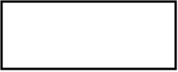 | Entity: Data object is real world entity or thing. It is represented by a rectangle shape. An entity is an object or concept about which you want to store information.
 | Attributes: An attribute is property of characteristic of an entity. It is represented by oval shape.
 | Relationship: Entity are connected each other via relations. Generally, relationships in binary because there are two entities are related to each other.
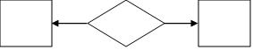 | Cardinality (One to One): An instance of entity A can relate to one instances of entity B.
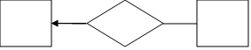 | Cardinality (One to Many): An instance of entity A can relate to one or many instances of B but we can only relate one instance of A.
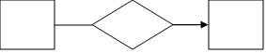 | Cardinality (Many to One): One or more instances of entity A can relate to one instances of B.
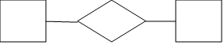 | Cardinality (Many to Many): One or more instances of entity A can relate to one more instance of entity B.

ER-Diagram:
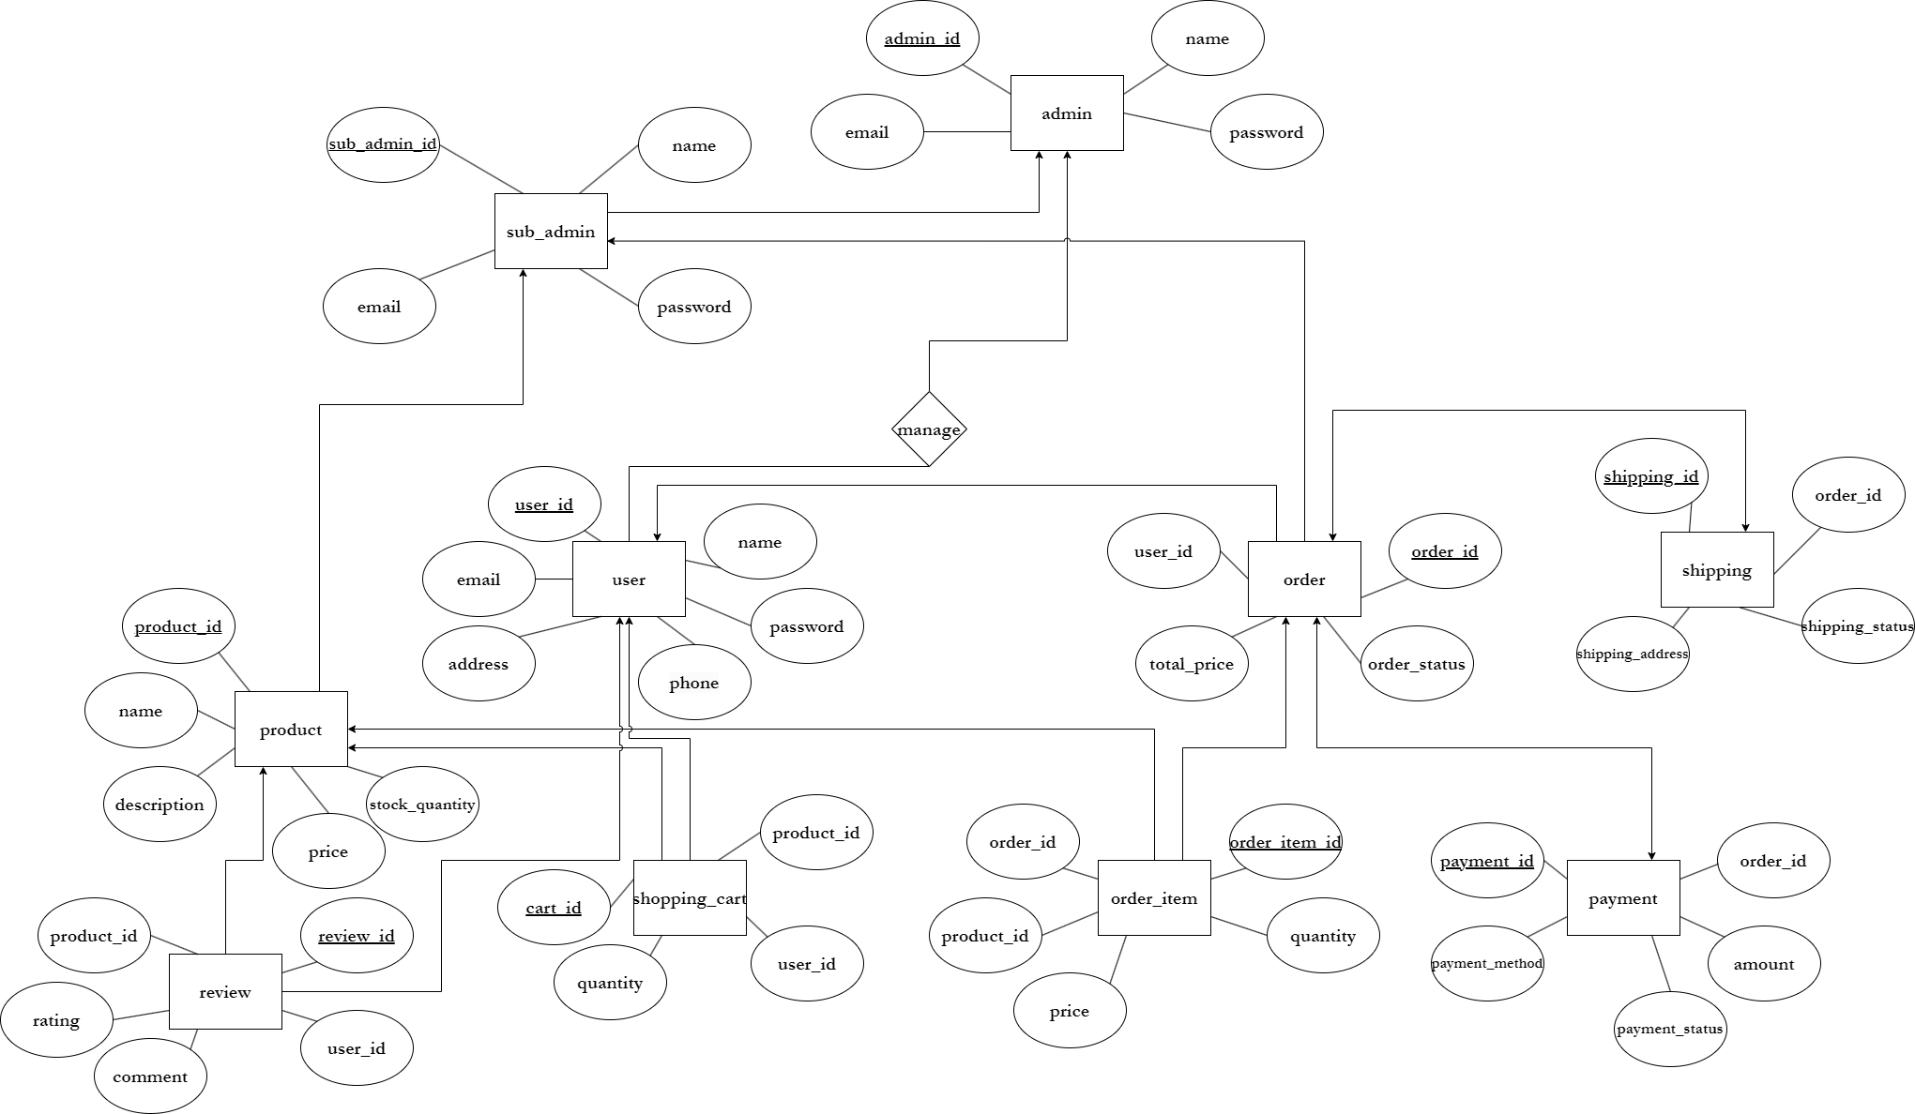
[Figure 7: ER Diagram]

CHAPTER-4
SYSTEM MODELING

4.1 Database Dictionary
1. Table Name: user
Primary Key: user_id
[Table 4: user]
SR.NO | FEILDNAME | DATATYPE(SIZE) | CONSTRAINT | DESCRIPTION
1 | user_id | INT(5) | Primary Key | Unique identifier for each user.
2 | name | VARCHAR(225) | Not Null | Full name of the user.
3 | email | VARCHAR(255) | Unique Key | Email address.
4 | password | VARCHAR(255) | Not Null | Hashed password for security.
5 | phone | VARCHAR(12) | Unique Key | Contact number of the user.
6 | address | TEXT(255) | Not Null | Shipping address for deliveries.

2. Table Name: products
Primary Key: product_id
[Table 5: products]
SR.NO | FIELDNAME | DATATYPE(SIZE) | CONSTRAINT | DESCRIPTION
1 | product_id | INT(3) | Primary Key | Unique identifier for each product.
2 | name | VARCHAR(255) | Not Null | Name of the product.
3 | description | TEXT(255) | Not Null | Detailed description of the product.
4 | price | DECIMAL(10,2) | Not Null | Price of the product
5 | stock_quantity | INT(3) | Not Null | Quantity available in stock.

3. Table Name: order
Primary key: order_id
Foreign Key: user_id
[Table 6: order]
SR.NO | FIELDNAME | DATATYPE(SIZE) | CONSTRAINT | DESCRIPTION
1 | order_id | INT(10) | Primary Key | Unique identifier for each order.
2 | user_id | INT(5) | Foreign Key | User who placed the order.
3 | total_price | DECIMAL(10,2) | Not Null | Total price of the order.
4 | shipping_price | TEXT(255) | Not Null | Shipping address for this specific order.
5 | order_status | ENUM(‘Pending’, ‘Shipped’, ‘Delivered’, ‘Cancelled’) | Not Null | Status of the order.
6 | Payment_method | ENUM(‘Pending’, ‘Completed’, ‘Failed’) | Not Null | Payment status of the order.

4. Table Name: order_item
Primary Key: order_item_id
Foreign Key: order_id, product_id
[Table 7: order_item]
SR.NO | FIELDNAME | DATATYPE(SIZE) | CONSTRAINT | DESCRIPTION
1 | order_item_id | INT(10) | Primary Key | Unique identifier for each order item.
2 | order_id | INT(10) | Foreign Key | Order to which the item belongs.
3 | product_id | INT(5) | Foreign Key | Product being ordered.
4 | quantity | INT(3) | Not Null | Quantity of the product ordered.
5 | price | DECIMAL(10,2) | Not Null | Price of the product ordered.

5. Table Name: shopping_cart
Primary Key: cart_id
Foreign Key: user_id, product_id
[Table 8: shopping_cart]
SR.NO | FIELDNAME | DATATYPE(SIZE) | CONSTRAINT | DESCRIPTION
1 | cart_id | INT(3) | Primary Key | Unique identifier for each cart item.
2 | user_id | INT(5) | Foreign Key | User who owns the cart.
3 | product_id | INT(3) | Foreign Key | Product added to the cart.
4 | quantity | INT(5) | Not Null | Quantity of the product added to the cart.

6. Table Name: payment
Primary Key: payment_id
Foreign key: order_id
[Table 9: payment]
SR.NO | FIELDNAME | DATATYPE(SIZE) | CONSTRAINT | DESCRIPTION
1 | payment_id | INT(10) | Primary Key | Unique identifier for each payment.
2 | order_id | INT(10) | Foreign Key | Order for which the payment was made.
3 | amount | DECIMAL(10,2) | Not Null | Total amount paid.
4 | payment_method | ENUM(‘PayPal’, ‘Cash on Delivery’) | Not Null | Method used for the payment.
5 | Payment_status | ENUM(‘Pending’, ‘Completed’, ‘Failed’) | Not Null | Status of the payment.

7. Table Name: review
Primary key: review_id
Foreign Key: product_id, user_id
[Table 10: review]
SR.NO | FIELDNAME | DATATYPE(SIZE) | CONSTRAINT | DESCRIPTION
1 | review_id | INT(10) | Primary Key | Unique identifier for each review.
2 | product_id | INT(3) | Foreign Key | Product being reviewed.
3 | user_id | INT(5) | Foreign Key | User who wrote the review.
4 | rating | INT(10) | Not Null | Rating given by user (1-5).
5 | comment | TEXT(255) | Not Null | Review text/comment

8. Table Name: shipping
Primary Key: shipping_id
Foreign Key: order_id
[Table 11: shipping]
SR.NO | FIELDNAME | DATATYPE(SIZE) | CONSTRAINT | DESCRIPTION
1 | shipping_id | INT(10) | Primary Key | Unique identifier for each shipping record.
2 | order_id | INT(5) | Foreign Key | Order associated with the shipping.
3 | shipping_address | TEXT(255) | Not Null | Address to which the order is shipped.
4 | shipping_status | ENUM(‘Pending’, ‘In Transit’, ‘Delivered’) | Not Null | Shipped status.

9. Table Name: admin
Primary Key: admin_id
[Table 12: admin]
SR.NO | FEILDNAME | DATATYPE(SIZE) | CONSTRAINT | DESCRIPTION
1 | admin_id | INT(3) | Primary Key | Unique identifier for each admin.
2 | username | VARCHAR(255) | Unique Key | Username of the user.
3 | email | VARCHAR(255) | Unique Key | Email address.
4 | password | VARCHAR(255) | Unique key | Password for security.

10. Table Name: sub_admin
Primary Key: sub_admin_id
[Table 13: sub_admin]
SR NO. | FEILDNAME | DATATYPE(SIZE) | CONSTRAINT | DESCRIPTION
1 | sub_admin_id | INT(5) | Primary Key | Unique identifier for each sub admin.
2 | username | VARCHAR(255) | Unique Key | Username of the user.
3 | email | VARCHAR(255) | Unique Key | Email address.
4 | password | VARCHAR(255) | Unique Key | Password for securtiy.

CHAPTER-5
TECHNICAL SPECIFICATION

5.1 Hardware Specification:
- 5.1.1 Ram: 4GB
- 5.1.2 Hard Drive Storage Needed: 20GB
- 5.1.3 Other Hardware Requirement: None
5.2 Platform:
- 5.2.1 Supported Operating System: Windows 10 or above LINUX and MacOS is also compatible.
- 5.2.2 Programmer Server: PythonAnywhere
5.3 Framework
- 5.3.1 Mark-up Language: HTML4 and HTML5
- 5.3.2 Programming Language: Python 3.12.4
5.4 Technical Specification:
- 5.4.1 Front-End: JavaScript ES6
- 5.4.2 Back-End: MySQL 8.0
- 5.4.3 IDE Tools: VS Code
- 5.4.4 UML Tools: draw.io
- 5.4.5 SRS Tools: Microsoft Word 2016.

5.5 DESIGN LAYOUT
Homepage:-
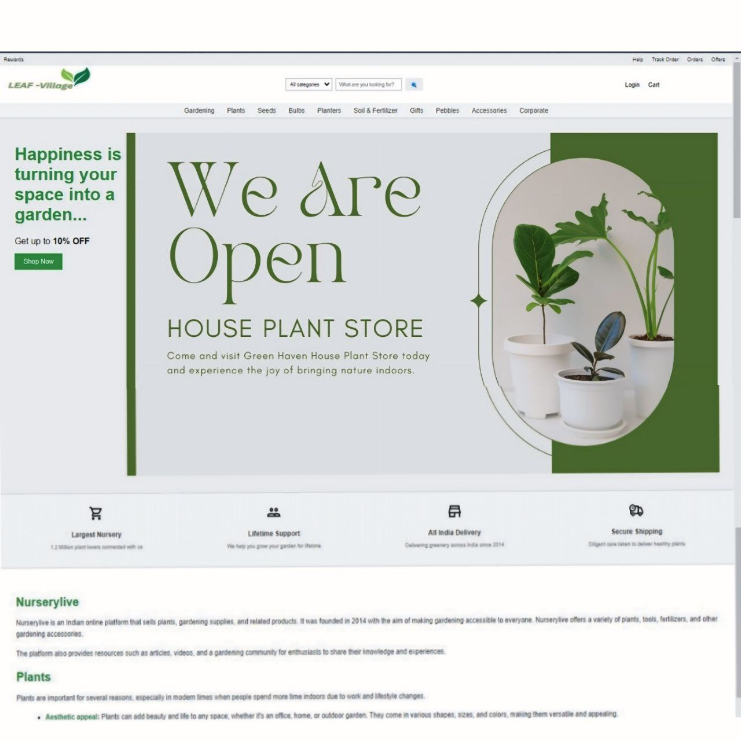
[Figure 8: Home Page]

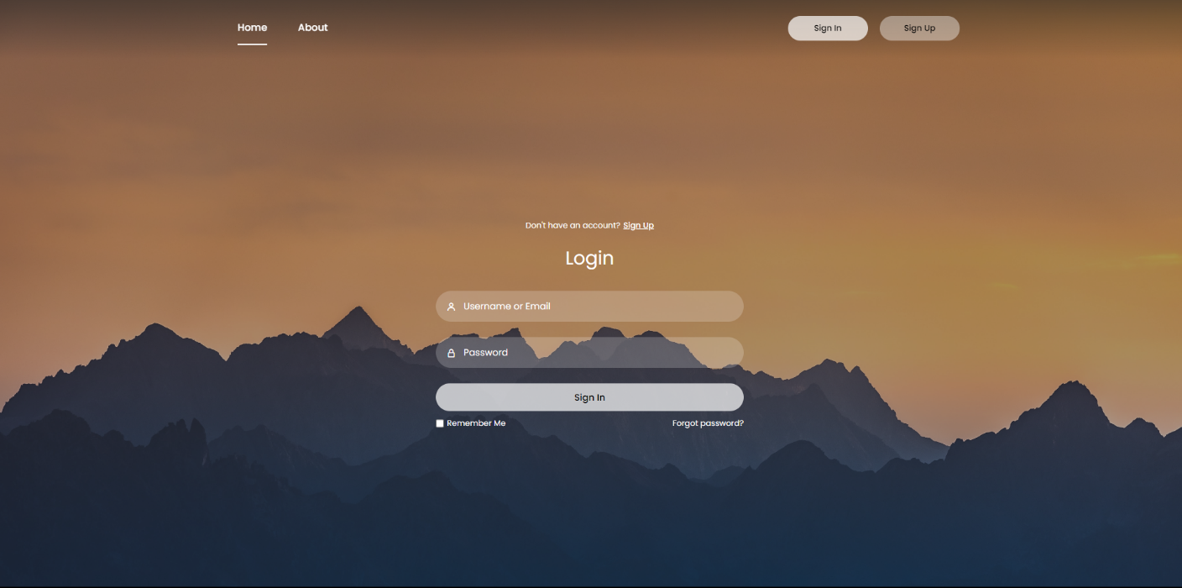
[Figure 9: User Login Page]

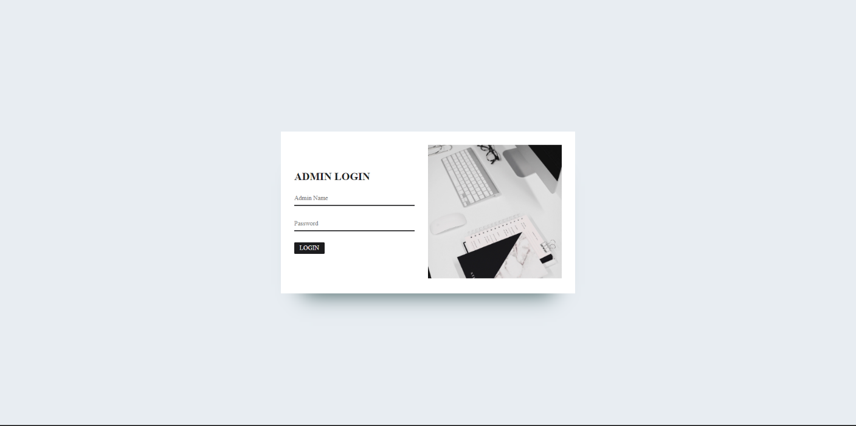
[Figure 10: Admin Login Page]

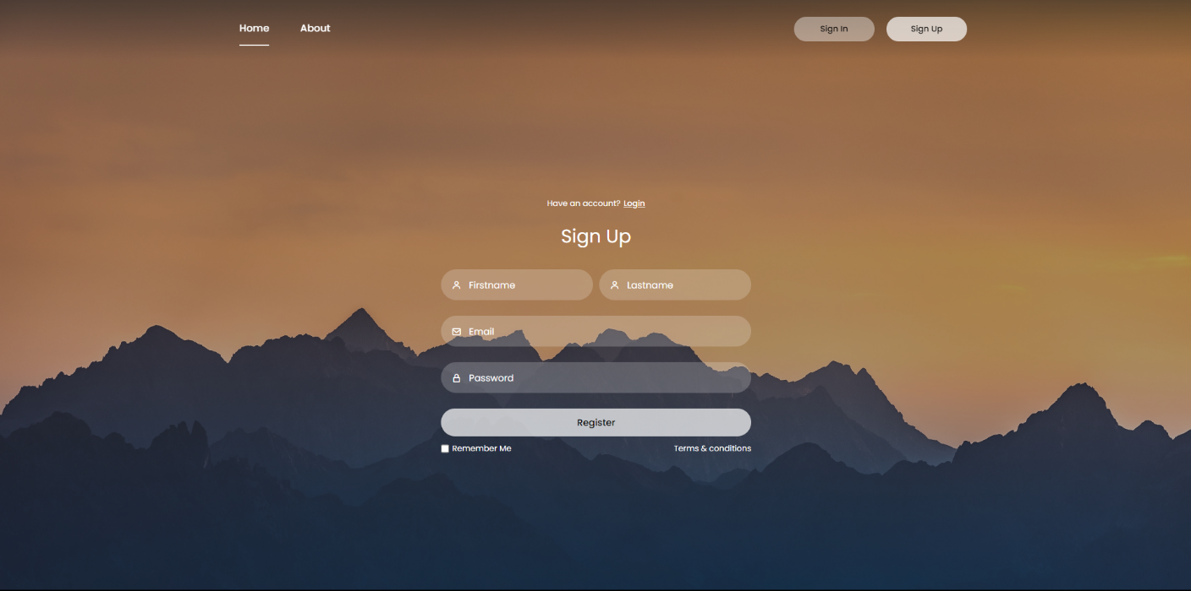
[Figure 11: User Sign up Page]

CONCLUSION
It was a great experience to design and implement the Leaf-Village (Plants and Greenery website) by using Python and to work on its documentation. While working on this project we have learned many things especially how to apply the concept of Python in modelling of real world system. This project is developed using Python, HTML, CSS, JavaScript and MySQL fully meets the objective of the system which it has been developed. This project is used for easy buying of plants and its tools to maintain and grow various types of herbs. The website allows you to buy plants, tools etc. The website also provides you with small manual of how to grow and maintain plants, which separates this website from the others.

BIBLIOGRAPHY

- BOOK REFERENCE
[1] Python crash course, Second Edition Author: Eric Matthes Published by: No Starch Press in 2019.
[2] JavaScript: The Definitive Guide, Seventh Edition Author: David Flanagan
Published by: O'Reilly Media in 2020.
[3] MySQL Cookbook: Solutions for Database Developers and Administrators, Fourth Edition Author: Paul DuBois Published by: O'Reilly Media in 2014.

- WEB REFERENCE
[1] W3school
Link: https://www.w3schools.com/django/django_admin.php
[2] W3school
Link: https://www.w3schools.com/js/js_validation_api.asp
[3] W3school
Link: https://www.w3schools.com/sql/sql_hosting.asp

